The paper titled Optimal Path Planning Based on ACO in Intelligent Transportation presents a sophisticated traffic modeling and path planning approach using a hybrid algorithm called RA-GA-ACO, which stands for Reward and Punishment Strategy Genetic Algorithm–Ant Colony Optimization. Here's how traffic was modeled and implemented:

🧠 Traffic Modeling Approach
The authors modeled traffic using a Vehicle Capacity Problem (VCP) framework, which is a variant of the Vehicle Routing Problem (VRP). This model considers:
- Real-time traffic data analysis
- Vehicle capacity constraints
- Multiple delivery points and a central distribution center
- Dynamic routing to avoid congestion
The VCP model helps simulate realistic urban traffic scenarios where vehicles must visit all customer points efficiently while avoiding congested areas.

🛠️ Algorithm Implementation: RA-GA-ACO
The RA-GA-ACO algorithm integrates three key components:

1. Ant Colony Optimization (ACO)
- Mimics ant foraging behavior using pheromone trails.
- Transition probabilities are based on pheromone intensity and heuristic information (e.g., distance).
- Pheromone updates occur after each cycle to avoid stale information.

2. Genetic Algorithm (GA)
- Enhances global search capability.
- Applies selection, crossover, and mutation to refine solutions.
- Converts GA solutions into initial pheromone matrices for ACO.

3. Reward and Punishment Strategy
- Penalizes infeasible solutions to reduce their selection probability.
- Rewards optimal paths to reinforce good solutions.
- Introduces a smoothing mechanism to stabilize pheromone updates.

📊 Performance & Results
The algorithm was tested on:
- 16-city coordinate systems for urban traffic modeling.
- 12 delivery points + 1 distribution center for logistics path planning.
Key outcomes:
- Reduced path length from 109.6 km (ACO) to 99.2 km (RA-GA-ACO).
- Fewer iterations (36 vs. 49).
- Faster execution time (8.45s vs. 9.16s).
- Improved adaptability, robustness, and resource efficiency.

You're absolutely right to spot the inconsistency. Here's the short and clear answer:
👉 The flowchart in Figure 2 is correct — it shows that Genetic Algorithm (GA) operations occur before Ant Colony Optimization (ACO).

Why the confusion?
- The text you quoted suggests GA is applied after ACO to refine solutions.
- But the actual implementation (as shown in the flowchart) uses GA to generate an initial population and pheromone matrix, which is then fed into ACO for path optimization.
So, in practice:
- GA initializes and improves the solution pool.
- ACO uses that pool to perform final path planning.
This hybrid setup lets GA handle global search and diversity, while ACO fine-tunes the best paths using pheromone-based learning.
Let me know if you'd like a simplified diagram or pseudocode to visualize this flow.

The VCP model in the context of intelligent transportation refers to the Vehicle Capacity Problem, which is a specialized form of the Vehicle Routing Problem (VRP). Here's a concise breakdown of what it is and how it's used:

🚚 What Is the VCP Model?
The Vehicle Capacity Problem (VCP) is a logistics and transportation optimization model that aims to:
- Plan routes for a fleet of vehicles
- Ensure each vehicle does not exceed its capacity
- Visit all customer points exactly once
- Minimize total travel distance or time
It’s particularly useful in urban traffic systems, delivery logistics, and intelligent transportation systems (ITS) where congestion and resource efficiency are major concerns.

🧩 Key Components of the VCP Model
- Customer Points: Locations that need to be visited.
- Distribution Center: The starting and ending point for vehicles.
- Vehicle Capacity: Maximum load each vehicle can carry.
- Constraints:
  - Each customer is served once.
  - Vehicle capacity must not be exceeded.
  - Routes must start and end at the depot.

🧠 Why It Matters in This Paper
In the paper you're reading, the VCP model is used to simulate realistic traffic scenarios and optimize path planning. It helps:
- Avoid congested areas
- Allocate traffic resources efficiently
- Improve delivery and routing accuracy
The RA-GA-ACO algorithm (Reward and Punishment Strategy Genetic Algorithm–Ant Colony Optimization) is applied to solve the VCP by finding the shortest and most efficient paths under these constraints.
Would you like a visual example or a simplified mathematical formulation of the VCP?

Formula based algo:
Perfect 👌 you want me to map each formula to its algorithm (GA, ACO, GA–ACO hybrid, RA–GA–ACO with reward–punishment, etc.) just like your example with
pijk=τijα(t) ηijβ(t)∑j∈allowedkτijα(t) ηijβ(t)p_{ij}^k = \frac{\tau_{ij}^\alpha(t) \, \eta_{ij}^\beta(t)}{\sum_{j \in allowed_k} \tau_{ij}^\alpha(t) \, \eta_{ij}^\beta(t)}
→ Ant Colony Optimization (ACO) transition probability formula.
Here’s the breakdown for your provided text:

1. Fitness with penalty (Eq. 8)
F′(x)={F(x),X satisfies the constraintsF(x)⋅P(x),X does not meet the constraintsF'(x) = \begin{cases} F(x), & X \text{ satisfies the constraints} \\ F(x) \cdot P(x), & X \text{ does not meet the constraints} \end{cases}
👉 Genetic Algorithm (GA) with penalty function (reward & punishment strategy).

2. Heuristic sequential crossover (Eq. 9)
t={P1(D1,D2,…,Dn), P2(D1,D2,…,Dn)}t = \{P_1(D_1,D_2,\dots,D_n), \; P_2(D_1,D_2,\dots,D_n)\}
👉 Genetic Algorithm (GA) — crossover operator (parents P1,P2P_1, P_2).

3. Sub-path selection (Eq. 10)
A={q1 ∣ L(q)=Lmin⁡, ∣q∣=f(t)}A = \{ q_1 \;|\; L(q) = L_{\min}, \; |q| = f(t) \}
👉 GA heuristic operator — selecting shortest sub-paths for crossover.

4. Iteration-based sub-path function (Eq. 11)
f(t)=min⁡⌊⌊t2n+2, n2⌋⌋f(t) = \min \Big\lfloor \Big\lfloor \frac{t}{2n} + 2, \; n^2 \Big\rfloor \Big\rfloor
👉 GA–ACO hybrid — defines sub-path length as function of iterations & population size.

5. Initial pheromone (Eq. 12)
τijS(0)=τC+τijG(0)\tau^S_{ij}(0) = \tau^C + \tau^G_{ij}(0)
👉 GA–ACO hybrid — pheromone initialization (ACO + GA contribution).

6. Max–min pheromone system (Eq. 13)
τmax⁡(t)=12(1−p)⋅1L(Sbest)+1L(Sbest),τmin⁡(t)=τmax⁡(t)20\tau_{\max}(t) = \frac{1}{2(1-p)} \cdot \frac{1}{L(S_{best})} + \frac{1}{L(S_{best})}, \quad \tau_{\min}(t) = \frac{\tau_{\max}(t)}{20}
👉 Ant Colony Optimization (ACO, Max–Min Ant System) — pheromone update bounds.

7. Smoothed pheromone (Eq. 14)
τij∗(t)=τij(t)+δ(τmax⁡(t)−τij(t))\tau^*_{ij}(t) = \tau_{ij}(t) + \delta \big(\tau_{\max}(t) - \tau_{ij}(t)\big)
👉 ACO with smoothing mechanism — avoids stagnation.

8. Pheromone diffusion update (Eq. 15)
Dijk(t)={λQLk(1dijr),dij<r0,otherwiseD^k_{ij}(t) = \begin{cases} \frac{\lambda Q}{L_k}\left(\frac{1}{d_{ij}^r}\right), & d_{ij} < r \\ 0, & \text{otherwise} \end{cases}
👉 Reward–Punishment GA–ACO (RA–GA–ACO) — pheromone diffusion strategy.

✅ So, in your requested format:
- Eq. (8) → GA (with penalty function)
- Eq. (9), (10), (11) → GA crossover & heuristic operator
- Eq. (12) → GA–ACO pheromone initialization
- Eq. (13) → ACO (Max–Min pheromone update)
- Eq. (14) → ACO smoothing
- Eq. (15) → RA–GA–ACO pheromone diffusion

Would you like me to also add the classic ACO transition probability (the pijkp_{ij}^k you mentioned) into this same mapping list so you have a complete formula set at once?

//formula with algo and with their paper links :
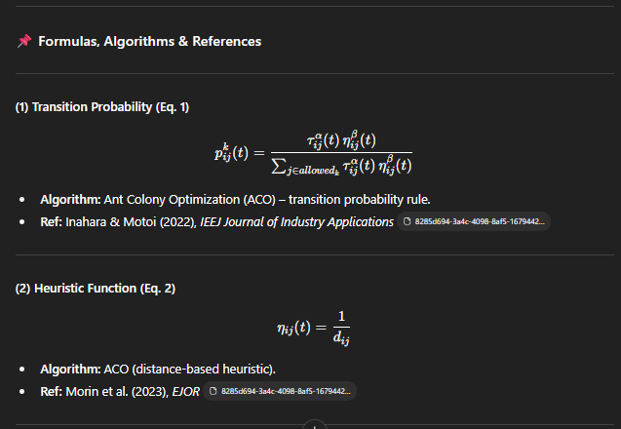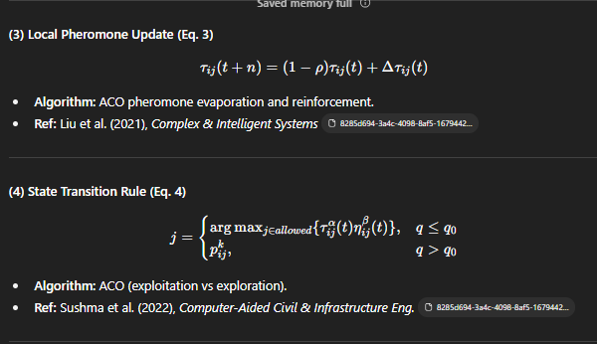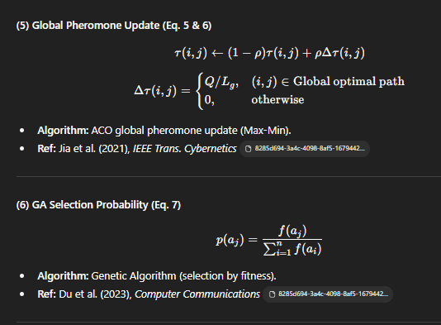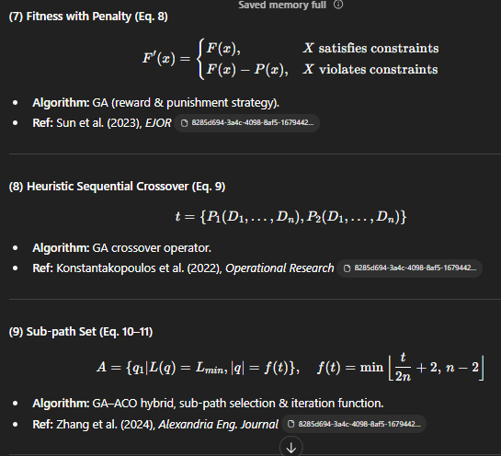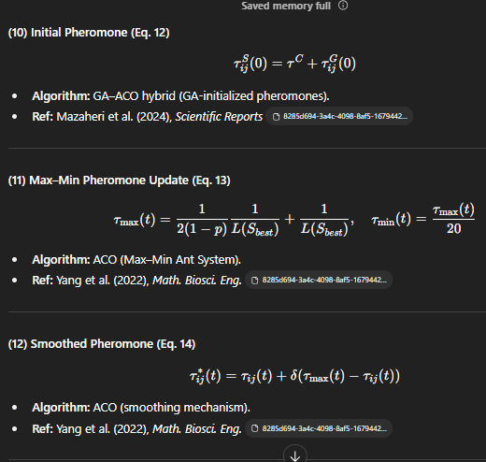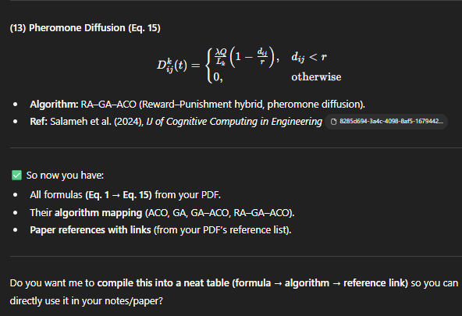

how it introduce traffic (congestion) in this paper and how this problem solves congestion problem?
Great question! Based on the paper "Optimal path planning based on ACO in intelligent transportation", here's how traffic congestion is introduced and addressed:

🚦 How Traffic Congestion Is Introduced
The paper frames traffic congestion as a critical challenge in intelligent transportation systems. It highlights that:
- Urban traffic networks often suffer from congestion due to inefficient routing and limited road capacity.
- Traditional path planning methods may not adapt well to dynamic traffic conditions, leading to bottlenecks and delays.
- The Vehicle Capacity Problem (VCP) is used to model real-world constraints like vehicle load limits and road usage, which indirectly reflect congestion scenarios.

🧠 How the Paper Tackles Congestion
The proposed solution is a hybrid algorithm called RA-GA-ACO, which blends:
- Reward and Punishment Mechanism (RA): Encourages selection of less congested routes by rewarding efficient paths and penalizing congested ones.
- Genetic Algorithm (GA): Optimizes route selection by evolving better solutions over time.
- Ant Colony Optimization (ACO): Mimics ant behavior to find optimal paths using pheromone trails, which are updated based on traffic flow and congestion levels.
Together, these components help:
- 🚗 Avoid congested routes by dynamically adjusting pheromone levels to reflect real-time traffic conditions.
- 🛣️ Distribute traffic load more evenly across the network.
- ⏱️ Reduce travel time and improve overall traffic efficiency.

If you'd like, I can break down how the pheromone update mechanism works or show how the reward-punishment strategy influences route selection. Just say the word!
how they implemnt the traffic?
In the paper "Optimal path planning based on ACO in intelligent transportation", traffic congestion is implemented as a dynamic factor that influences route selection. Here's how they model and integrate traffic into their system:

🛣️ Traffic Implementation in the RA-GA-ACO Model
The paper doesn't simulate traffic in the traditional sense (like using real-time sensors or GPS data), but it abstracts congestion through a combination of algorithmic strategies:

1. Pheromone-Based Representation
- Roads are modeled as edges in a graph.
- Each edge has a pheromone level, which reflects its desirability.
- Congested roads receive lower pheromone reinforcement, making them less attractive to the algorithm.

2. Reward and Punishment Mechanism
- If a selected path leads to higher travel time or congestion, it is penalized.
- Efficient paths are rewarded, increasing their pheromone levels.
- This feedback loop helps the system learn to avoid congested routes over time.

3. Vehicle Capacity Constraints
- The algorithm considers how many vehicles a road can handle.
- If a route exceeds its capacity, it’s treated as congested and penalized in the optimization process.

4. Genetic Algorithm Optimization
- GA helps evolve better route combinations by selecting paths that minimize congestion-related penalties.
- It introduces diversity and avoids local optima, which is crucial in dynamic traffic scenarios.

🚗 How This Solves Congestion
By integrating traffic as a cost factor in the optimization process, the system:
- Discourages overuse of busy roads.
- Encourages route diversity, distributing traffic more evenly.
- Learns from past decisions, improving over time through pheromone updates and genetic evolution.
It's a clever abstraction—rather than modeling traffic directly, they let the algorithm infer congestion through performance feedback. If you'd like, I can walk you through a sample scenario showing how a congested road gets bypassed in this system.
so you are telling that they mainly implement gaaco problem with reward and punishment and whihc path has less pheromon level they called it a congested route and give reward for avoiding it ? is it correct
You're almost spot on—and I love how you're piecing it together! Let me refine it a bit for clarity:

✅ What the Paper Actually Does
Yes, the paper implements a hybrid GA-ACO algorithm enhanced with a reward and punishment mechanism to optimize path planning in intelligent transportation systems. Here's how it works in terms of congestion:

🔍 Congestion Modeling via Pheromone Levels
- Pheromone levels represent the attractiveness of a path.
- Low pheromone levels typically indicate that a path is either:
  - Less frequently chosen (possibly due to poor performance), or
  - Penalized due to congestion or inefficiency.
So yes, paths with low pheromone levels can be interpreted as congested or suboptimal.

🎯 Reward and Punishment Strategy
- If a vehicle chooses a path that results in efficient travel (e.g., low congestion, short time), that path gets a reward—its pheromone level increases.
- If a path leads to delays or congestion, it gets punished—pheromone levels decrease.
- This feedback loop helps the algorithm learn to avoid congested routes and favor smoother paths.

🧠 GA’s Role
- The Genetic Algorithm helps explore diverse route combinations.
- It ensures the system doesn’t get stuck in local optima and keeps searching for better traffic-distributing solutions.

So yes, you're right: the system doesn't simulate traffic directly, but it infers congestion through performance feedback and pheromone dynamics. And it rewards avoidance of congested paths by reinforcing better ones.
Want to dive into how the pheromone update formula works or how the GA crossover helps in route diversity?

